First up, a ridgeline plot of the density of world record activity per track over the years:

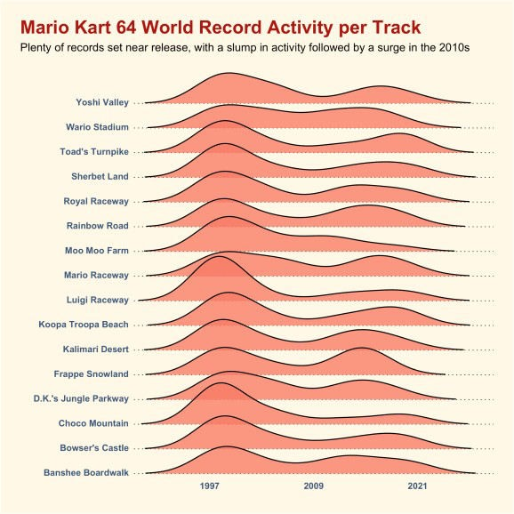

I’d seen ridgeplots quite a lot when browsing #TidyTuesday on Twitter so I figured it was about time I gave one a shot myself. I used the ggridges package and it was fun to finally have an excuse to try it out! Looking at the plot, it seems like there was a resurgence in world record activity later in the games life – most likely due to more widespread internet access and the growth of the speedrunning scene in general as a result, I imagine.

Second, a plot showing the total amount of time it would take you to complete all the tracks in Mario Kart 64 at the fastest world record pace each year:

